Standard error estimates

The variance of the sample mean is the variance of X, say, among different samples from the same underlying distribution. Supposing that you have samples of size N and then for each sample calculate the mean, X. Then theoretically, the variance of X is:

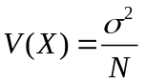

where σ is the true population standard deviation.

The measurement program output the “Standard Error in Mean” which is given by the

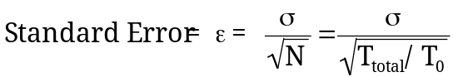

Note: N is the number of independent samples.

The measurement program estimates T₀ by integrating the area under Autocorrelation down to 25% and multiplying this value by a factor of 2. The number of independent samples can then be calculated from the total time trace length T_{total} divided by T₀.

The general expression for the variance of a sample variance, s², is given in Cochran, 1963. When s² is calculated for many samples of size N, based on the same underlying distribution, the theoretical variance of s² is

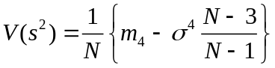

where m₄ is the central fourth moment of the underlying distribution. For the normal family of distributions:

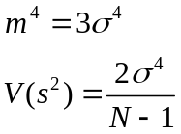

and the standard error of the sample variance is simply the square root of V(s²):

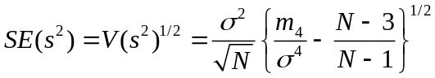

Cochran, WG, 1963. Sampling Techniques, 2nd Edition. John Wiley and Son Ltd.

Alan Robins and Paul Hayden

